Public Mobile Network

📶 What Is a Public Mobile Network?
# Source: Chatgpt (GPT-5-Mini) at [1/23/2026]
A Public Mobile Network is a telecommunication network operated by licensed mobile network operators (MNOs) that provides wireless voice, text, and data services to the general public.
📡 It’s the mobile network you use every day — like Vodafone, Orange, AT&T, or Verizon.

🧩 Key Characteristics:
# Source: Chatgpt (GPT-5-Mini) at [1/23/2026]
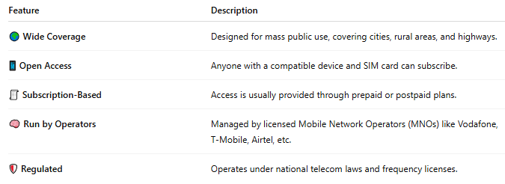

Feature | Description
🌍 Wide Coverage | Designed for mass public use, covering cities, rural areas, and highways.
📱 Open Access | Anyone with a compatible device and SIM card can subscribe.
🧾 Subscription-Based | Access is usually provided through prepaid or postpaid plans.
🧠 Run by Operators | Managed by licensed Mobile Network Operators (MNOs) like Vodafone, T-Mobile, Airtel, etc.
🛡️ Regulated | Operates under national telecom laws and frequency licenses.

🏗️ Components of a Public Mobile Network:
# Source: Chatgpt (GPT-5-Mini) at [1/23/2026]
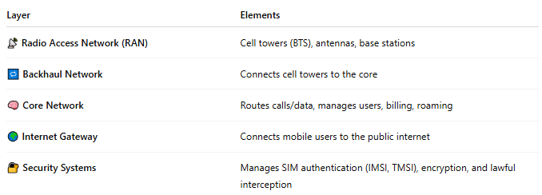

Layer | Elements
📡 Radio Access Network (RAN) | Cell towers (BTS), antennas, base stations
🔁 Backhaul Network | Connects cell towers to the core
🧠 Core Network | Routes calls/data, manages users, billing, roaming
🌍 Internet Gateway | Connects mobile users to the public internet
🔐 Security Systems | Manages SIM authentication (IMSI, TMSI), encryption, and lawful interception

✅ Services Provided by Public Mobile Networks:
# Source: Chatgpt (GPT-5-Mini) at [1/23/2026]
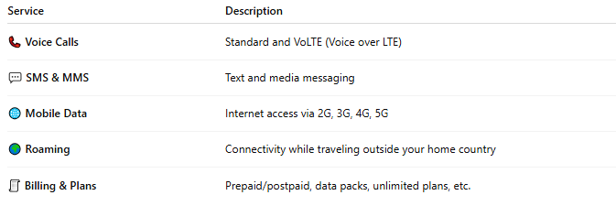

Service | Description
📞 Voice Calls | Standard and VoLTE (Voice over LTE)
💬 SMS & MMS | Text and media messaging
🌐 Mobile Data | Internet access via 2G, 3G, 4G, 5G
🌍 Roaming | Connectivity while traveling outside your home country
🧾 Billing & Plans | Prepaid/postpaid, data packs, unlimited plans, etc.

🆚 Public vs Private Mobile Network:
# Source: Chatgpt (GPT-5-Mini) at [1/23/2026]
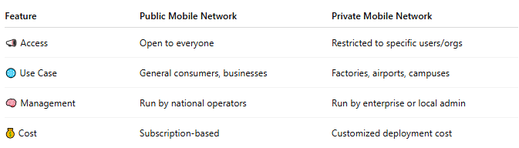
Feature | Public Mobile Network | Private Mobile Network
📣 Access | Open to everyone | Restricted to specific users/orgs
🌐 Use Case | General consumers, businesses | Factories, airports, campuses
🧠 Management | Run by national operators | Run by enterprise or local admin
💰 Cost | Subscription-based | Customized deployment cost

📖 Summary:
# Source: Chatgpt (GPT-5-Mini) at [1/23/2026]
A Public Mobile Network is the mobile infrastructure that lets you:
- 📞 Make calls
- 💬 Send texts
- 🌐 Access the internet
- 🌍 Roam globally
It’s managed by licensed operators, regulated by governments, and built to connect millions of people and devices seamlessly.

